**Second Baptist Church, est. 1848**

**816 Third Street, N.W., Washington, D.C. 20001**

***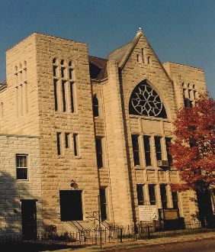***

SECOND HANDS

**VOLUME XXI Number 38**  **Sunday, September 20, 2020**

**Annual theme:  *Loving God with All Our Heart”***

Master, which is the great commandment in the law? Jesus said unto him, Thou shalt love the Lord thy God with all thy heart, and with all thy soul, and with all thy mind. This is the first and great commandment.

Matthew 22:36-38

**OUR CALENDAR**

**AT A GLANCE**

**Today, Sunday, September 20**

**10:00 a.m.** Sunday School

Topic “Victorious Love”,

Genesis 42

**11:00 a.m.** Worship Service

**Tuesday, September 22**

**6:00 p.m.** Bible Study and Prayer Meeting, Conference call in 1-866-783-6229,

Code 712634#

Acts Chapter 6

**Sunday, September 27**

**10:00 a.m.** Sunday School

Topic “Revealed Love”,

Genesis 45

**11:00 a.m.** Pastor’s Anniversary Worship Service

**Tuesday, September 29**

**6:00 p.m.** Bible Study and Prayer Meeting, Conference call in 1-866-783-6229,

Code 712634#

Acts Chapter 7

**Sunday, October 4**

**10:00 a.m.** Sunday School

Topic “Love that Intercedes”,

I Samuel 19

**11:00 a.m.** Homecoming and Worldwide Communion

Please send any news or announcements for *Second Hands* to the church before 10:30 a.m. on the **Wednesday** preceding publication.

Church Office: 202.842.0233 \* Facsimile: 202.842.4574 \* Email: [sb**c**nwdc@verizon.net](mailto:sbcnwdc@verizon.net) \* Website: [www.secondbaptistchurchdc.org](http://www.secondbaptistchurchdc.org)

**Verse of the Week**

“…call upon me in the day of trouble: I will deliver thee, and thou shalt glorify me.”

***Psalm 50:15***

**Congregational Prayer**

Almighty and merciful God,  
source of all life, health and healing, look with grace on our world. Protect us in the midst of the serious challenges that assail us and in your fatherly providence give healing to the sick, insight to those who care for them and success to those working to get rid of this thorn in our side. Strengthen us to stand and go through with faith, any challenge or hindrance or setbacks that may come our way to limit how far we can take the Gospel in Jesus name. Amen.

**September Birthdays**

|  |  |
| --- | --- |
| Kimberly Baskerville | 1 |
| Gideon Chofor | 6 |
| Deandre Coleman | 6 |
| Karen Lucas | 15 |
| Albert Dixon, Jr. | 17 |
| Donte Robinson | 20 |
| Min. Kenneth Thomas | 23 |
| Erica Baker | 24 |
| Jordan Heath | 24 |
| Dr. James E. Terrell | 29 |

Black

Lives

Matter

**Quote of Week**

“Our mistreatment was just not right, and I was tired of it.”

*Rosa Parks*



Sunday, September 20, 2020 Page 2 Second Hands

**See Us on Facebook**

You may find today’s Sunday sermon on [www.facebook.com/secondbaptistchurchdc](http://www.facebook.com/secondbaptistchurchdc). Once on our page, go to “Posts”.

**Second Baptist Church Services**

**Communion**

11:00 a.m. each Second and Fifth Sunday

**Sunday School**

10:00 a.m. each Sunday

**Baptism**

Second Sunday

**Communion, Hospital and Home Visits**

If you, or someone you know, would like to be visited by the pastor, please do not hesitate to call the church office to make arrangements.

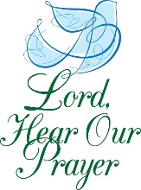**Pray For**

The Bartley Family, Sis. Charlton Baxter,Sis. Cynthia Broadus,Sis. Denise Brooks,Bro. Ronald Brooks,Sis. Sarah Campbell, Atty. Charles Craig, Rebecca T. Dent, Bro. Tyrone Foreman, Sis. Thelma Goodwin, Sis. Ruth Gordon, Deas. Elsie Hammond, Bro. Jersey Hilton, Deas. Mary Hodges (N.C.), Deas. Patricia Ireland, Bro. Wayne Ireland, Sis. Kandis Jacobs and Family, Sis. Tamiko Jackson and Family, Sis. Patricia Jackson, Deas. Sheila Jackson, Bro. Philip Jordan, Sis. Josephine Lawrence, Officer Lucas, Sis. Carolyn Kelly and Family, The Lewis Family, Sis. Rebecca King, The Martin Family, Sis. Linda Cox Miko, Sis. Angela Butler Mills, Bro. Leonard Mills, Deas. Ozella Mitchell, Sis. Cheryl Morning, Bro. Richard Noble, Bro. Elmer Powell, Sis. Lois Pulliam, Sis. LaNiece Proctor, The Quick Family, Sis. Diamond Scott, Sis. Stephanie Scott, Sis. Constance Smith, Bro. Rufus T. Stevenson, Deas. Georgia Thomas, Bro. Danny Tonzi, Two Year Old Joseph, Sis. Belinda Williams, Bro. Dwight Wilson, Bro. Leroy Wilson

Men and Women in Military Service

The People of Cameroon

The Young People of DACA

The Victims of Gun Violence

Those Looking for Work

Victims of the coronavirus

**Prayer list**

Please contact the church office to have names added to our Prayer Request List.

**\_\_\_\_\_\_\_\_\_\_\_\_\_\_\_\_\_\_\_\_\_\_\_\_\_**

***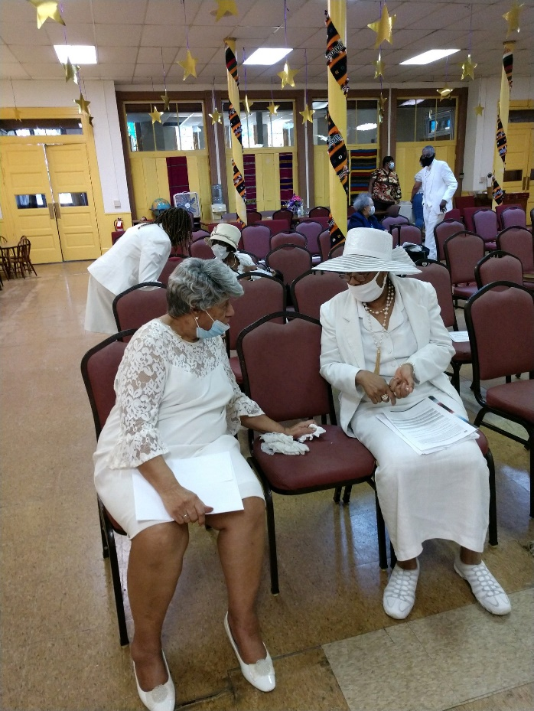***

**Tr. Vernelle Hamit and Dea. Sharon Malone talking after service last Sunday**

Please give notices and announcements of vital statistics, important events and other news for the *Second Hands* to the church office by **Wednesday** preceding the Sunday on which you wish publication We thank you for your input.

Church Office: 202.842.0233 \* Facsimile: 202.842.4574 \* Email: [sbcnwdc@verizon.net](mailto:sbcnwdc@verizon.net) \* Website: [www.secondbaptistchurchdc.org](http://www.secondbaptistchurchdc.org)

If you would like to get in touch with our pastor, Dr. Terrell, you can contact him at: 202-841-2479 or 202-584-1524.

Rev. Dr. James E. Terrell, Pastor

Rev. James S. Terrell, Assistant to the Pastor

James Shird, Chairman, Board of Deacons

Vernelle Hamit, Chairman, Board of Trustees

Wandra Brown, Chairman, Board of Deaconesses

**Announcements**

**Homecoming and** **Worldwide Communion**

Our Annual Homecoming Service and Worldwide Communion Observance will be held on Sunday, October 4, 2020 at 11:00 a.m. We will give special recognition to our members of 50 years or more. We are looking forward to seeing you, your family and friends.

**Health Workshop**

**First Rising Mt. Zion Baptist Church is host to a health workshop on** “Faith, Fitness, and Food” which will be held on **Saturday, October 3, 2020, at 10:00 a.m. via Zoom. Join by computer, laptop, tablet, other electronic devices or by telephone.** **Please RSVP to** [arlenelw@comcast.net](mailto:arlenelw@comcast.net" \t "_blank) **by Friday, September 18, 2020 to receive the Zoom access information and handouts.** Bro. Paul Heath will be one of the presenters.

****

This fall, Second Baptist Church will celebrate the Twenty-third Anniversary of Dr. James E. Terrell as our Pastor. The Pastor’s Anniversary Service will be held on Sunday, September 27 at 11:00 a.m.