**Second Baptist Church, est. 1848**

**816 Third Street, N.W., Washington, D.C. 20001**

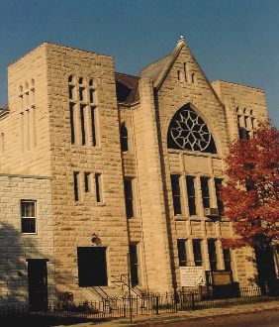

SECOND HANDS

**VOLUME XXI Number 28**  **Sunday, July 12, 2020**

**Annual theme:  *Loving God with All Our Heart”***

Master, which is the great commandment in the law? Jesus said unto him, Thou shalt love the Lord thy God with all thy heart, and with all thy soul, and with all thy mind. This is the first and great commandment.

Matthew 22:36-38

**OUR CALENDAR**

**AT A GLANCE**

**Today, Sunday, July 12**

**10:00 a.m.** Sunday School

**11:00 a.m.** Holy Communion

Rev. Dr. James E. Terrell, Preaching

**Sunday, July 19**

**10:00 a.m.** Sunday School

**11:00 a.m.** Worship Service

Rev. Dr. James E. Terrell, Preaching

**Sunday, July 26**

**11:00 a.m.** Worship Service

Rev. James S. Terrell, Preaching

**Sunday, August 2**

**11:00 a.m.** Worship Service

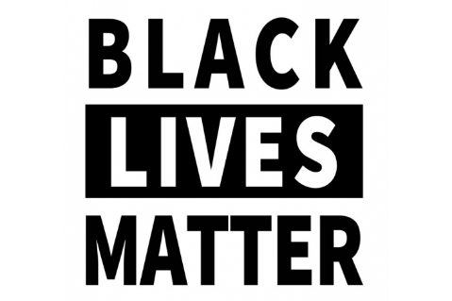

Please send any news or announcements for *Second Hands* to the church before 10:30 a.m. on the **Wednesday** preceding publication.

Church Office: 202.842.0233 * Facsimile: 202.842.4574 * Email: [sb**c**nwdc@verizon.net](mailto:sbcnwdc@verizon.net) * Website: [www.secondbaptistchurchdc.org](http://www.secondbaptistchurchdc.org)

**Verse of the Week**

“For everyone born of God overcomes the world. This is the victory that has overcome the world, even our faith. Who is it that overcomes the world? Only the one who believes that Jesus is the Son of God”

***I John 5:4-5***

**Congregational Prayer**

Loving God, we give You thanks for giving us another day. In these most important days and activities here in Your Church, we ask You to send Your spirit of wisdom as we struggle to do the work that has been entrusted to this Church. Inspire us to work together with love. Please join our efforts to accomplish what our community needs to live in a prosperous and secure future. Please keep all the members of this Church and all who work for Your kingdom in good health, that we might faithfully fulfill the great responsibility given to us by You, our Saviour. Bless us this day and everyday. May our worship and all we do be for Your greater honor and glory. Amen.

**SBC Worship Service**

The District of Columbia is now in Phase 2 of the Covid-19 Pandemic recovery. Today, July 5, Second Baptist continues to worship in the Lower Sanctuary sitting six feet apart with people wearing masks. You may also find today’s Sunday’s sermon on [www.facebook.com/secondbaptistchurchdc](http://www.facebook.com/secondbaptistchurchdc). Once on our page, go to Posts.

**July Birthdays**

|  |  |
| --- | --- |
| Joyce Woodson | 1 |
| William Melby, Jr. | 5 |
| Thaddeus Smith, Jr. | 7 |
| Thapura Smith | 7 |
| Emanuel Campbell | 9 |
| Leroy Wilson (97) | 9 |
| Jannel Alston | 10 |
| Vaughn Bennett | 10 |
| Brock Brown | 17 |
| Damione Sumpter | 17 |
| Shileathea Smith | 17 |
| Lena M. Bradley | 20 |
| Tai Kemp-Rotan | 23 |
| Joseph Gatling | 24 |
| Satra Smith | 26 |
| Janice Tyler | 26 |
| Mary Hodges | 29 |
| Breana Bost | 30 |
| Breana Doodo | 30 |

Sunday, July 12, 2020 Page 2 Second Hands

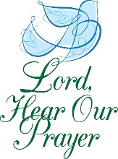

**Prayer List**

The Bartley Family

Sis. Charlton Baxter

Sis. Cynthia Broadus

Sis. Denise Brooks

Bro. Ronald Brooks

Sis. Sarah Campbell

Atty. Charles Craig

The Willie Dunham Family

The Gatling Family

Sis. Thelma Goodwin

Sis. Ruth Gordon

Deas. Elsie Hammond, *at home*

Deas. Mary Hodges (N.C.)

Tr. Vernelle Hamit and Family

Bro. Wayne Ireland

Sis. Kandis Jacobs and Family

Sis. Tamiko Jackson and Family

Sis. Patricia Jackson

Deas. Sheila Jackson

Sis. Josephine Lawrence

Officer Lucas

Sis. Carolyn Kelly and Family

The Lewis Family

Sis. Doris Little and Family

Sis. Rebecca King

Sis. Marjean Rae Martin

Sis. Linda Cox Miko

Sis. Angela Butler Mills

Bro. Leonard Mills

Deas. Ozella Mitchell

Sis. Cheryl Morning

Bro. Richard Noble

The Nolton Family

Bro. Elmer Powell

Sis. Lois Pulliam

Sis. LaNiece Proctor

The Quick Family

Sis. Diamond Scott

Sis. Stephanie Scott

Sis. Constance Smith, *at home*

The Smith Family

Bro. Tyrone Stevens

Please give notices and announcements of vital statistics, important events and other news for the *Second Hands* to the church office by **Wednesday** preceding the Sunday on which you wish publication We thank you for your input.

Church Office: 202.842.0233 * Facsimile: 202.842.4574 * Email: [sbcnwdc@verizon.net](mailto:sbcnwdc@verizon.net) * Website: [www.secondbaptistchurchdc.org](http://www.secondbaptistchurchdc.org)

If you would like to get in touch with our pastor, Dr. Terrell, you can contact him at: 202-841-2479 or 202-584-1524.

Rev. Dr. James E. Terrell, Pastor

Rev. James S. Terrell, Assistant to the Pastor

James Shird, Chairman, Board of Deacons

Vernelle Hamit, Chairman, Board of Trustees

Wandra Brown, Chairman, Board of Deaconesses

Bro. Rufus T. Stevenson

Deas. Georgia Thomas

Bro. Danny Tonzi

Two Year Old Joseph

Sis. Belinda Williams

Bro. Dwight Wilson

The James Wilson Family

Bro. Leroy Wilson

Men and Women in Military Service

The People of Cameroon

The Young People of DACA

The Victims of Gun Violence

Those Looking for Work

Victims of the coronavirus

**Minister Letetia Barrett**

We welcome Minister Letetia Barrett who joined church on July 5. She is to receive the Right Hand of Fellowship today.

**Announcements**

**Covid-19 Testing**

The District of Columbia is hosting several free testing sites. To learn more and find a testing site near you, please visit <https://coronavirus.dc.gov/testing>

**National Museum of African American History and Culture Digital Progr5ams**

This summer, the National Museum of African American History and Culture (NMAAHC) Teaching and Learning team is piloting innovative digital programs to keep young minds expanding in fresh and exciting ways. For more information, please call 844-750-3012.

* **Grades 3–12**

**Summer Reading Challenge**

For more information, please visit <https://nmaahc.si.edu/learn/students/reading-through-galleries>

* **Grades 6–12**   
  **Artists at Home**  
  **Wednesdays through August at 12 p.m. Eastern or 9 a.m. Pacific Time**

To register, please visit <https://nmaahc.si.edu/learn/students/artists-home>

* **Grades 6–12**  
  **Through the Window and into the Mirror: “Meet” African American STEM Professionals**  
  **Fridays, July 10–August 28 at 2 p.m. Eastern and 11 a.m. Pacific Time**

To register, please visit <https://nmaahc.si.edu/learn/students/through-window-and-mirror-narratives-african-american-stem-professionals>

* **Grades K–8  
  Take a Summer Road Trip with the Smithsonian  
  Download your free activity guide at <https://drive.google.com/file/d/1cMqb9-PNbLPidEF-9jSm9CjlDs2Efksi/view>**

**Summer Worship**

Second Baptist worship services will be held in the Lower Sanctuary for the few Sundays.