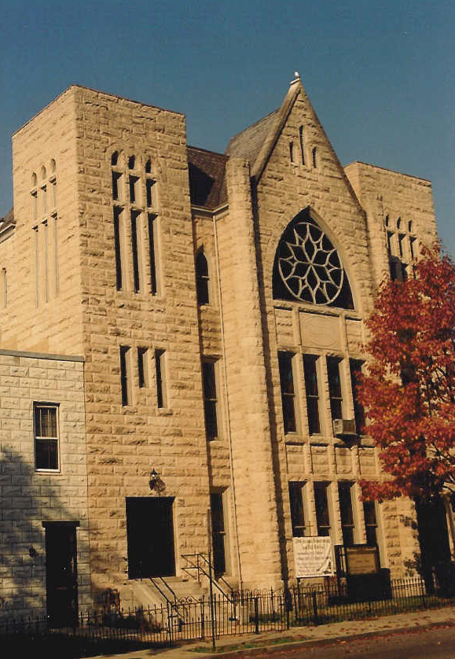Morning Worship Service

**Sunday, October 18, 2020**

Order of Service

Devotional Hymn *“Lord I Want to Be a Christian” 490 (a capella)*

Call to Worship *Matthew 11:28-30*

Invocation

Choral Response *“Thank You, Lord” (Insert)*

Hymn of Praise *“In the Garden”109*

First Scripture *579 “Faith”*

Hymn of Consecration *“Standing On the Promises” 279*

Second Scripture *Matthew 4:8-18*

Concerns of the Church Pastor

Hymn of Preparation

The Sermon: “*God’s Amazing Grace”* Dr. Terrell

*The same heard Paul speak: who stedfastly beholding him, and perceiving that he had faith to be healed,Said with a loud voice, Stand upright on thy feet. And he leaped and walked. Matthews 14:9-10*

Invitation to Christian Discipleship Hymn *“He’s Sweet I Know” 224*

Announcements

Welcome to Visitors

Offering and Prayer *“Can’t Nobody Do Me Like Jesus ” (Insert)*

*All Things Come of Thee 536 - Offertory Prayer Deacon –*  *Doxology 527*

Morning Prayer

Meditative Hymn *“The Question Is” (Insert)*

Benediction

Hymn of Service *“All Day Long” (Insert)*

Musicologist: Trustee Mariessa T. Brown

*Hymns are taken from The New National Baptist Hymnal*

**Second Baptist Church, est. 1848**

**816 Third Street, N.W., Washington, D.C. 20001**

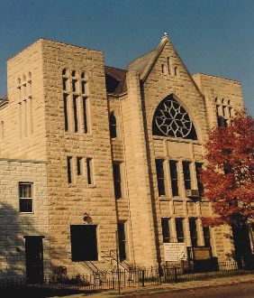

SECOND HANDS

**VOLUME XXI Number 42**  **Sunday, October 18, 2020**

**Annual theme:  *Loving God with All Our Heart”***

Master, which is the great commandment in the law? Jesus said unto him, Thou shalt love the Lord thy God with all thy heart, and with all thy soul, and with all thy mind. This is the first and great commandment.

Matthew 22:36-38

**OUR CALENDAR**

**AT A GLANCE**

**Today, Sunday, October 18**

**10:00 a.m.**  Sunday School

Topic “Love for Neighbors”

Luke 10

**11:00 a.m.** Worship Service, Dr. James E. Terrell, Preaching

**Tuesday, October 20**

**6:00 p.m.** Bible Study and Prayer Meeting*, Acts Chapter 15

**Sunday, October 25**

**10:00 a.m.**  Sunday School

Topic “Love Never Fails”

I Corinthians 13

**11:00 a.m.** Worship Service, Rev. James S. Terrell, Preaching

**Tuesday, October 27**

**6:00 p.m.** Bible Study and Prayer Meeting*, Acts Chapter 16

**Sunday, November 1**

**10:00 a.m.**  Sunday School

Topic “Serving Love”

John 13

**11:00 a.m.** Stewardship Worship Service, Dr. James E. Terrell, Preaching

Daylight Savings Time Ends

**Tuesday, November 3**

Election Day – Please Vote

**6:00 p.m. NO** Bible Study and Prayer Meeting*, Acts Chapter 16

Please send any news or announcements for *Second Hands* to the church before 10:30 a.m. on the **Wednesday** preceding publication.

Church Office: 202.842.0233 * Facsimile: 202.842.4574 * Email: [sb**c**nwdc@verizon.net](mailto:sbcnwdc@verizon.net) * Website: [www.secondbaptistchurchdc.org](http://www.secondbaptistchurchdc.org)

*Prayer Meeting and Bible Study

Conference call in

1-866-783-6229

Code 712634#

**Verse of the Week**

“Be still and know that I am God: I will be exalted among the heathen, I will be exalted in the earth.”

***Psalm 46:10***

**Congregational Prayer**

Praise God, I pray for the strength to be thankful for today in the midst of challenges and to thank God for his favor and grace. Lord, help me to focus on what the Holy Spirit is doing in my life.  I am not alone in my fight against fear; I have the Holy Spirit and the angels standing with me and in me. Thank you, Lord, for the victories in my life, You, Jesus, make allowance for my weaknesses and unbelief.  When fear controls my thoughts and actions help me to rest upon the love, grace, mercy, peace and the righteousness of Jesus who is our shield and redeemer. Thank you, Lord, for helping me overcome and delivering me from my fear of struggle. Help me to respect my enemies and to be as wise as a serpent and harmless as a dove. In the name of Jesus I pray. Amen.

**October Birthdays**

|  |  |
| --- | --- |
| Carrol Alonzo Jackson | 1 |
| Rev. Dr. Ray E. McKissic | 3 |
| Georgia Thomas | 3 |
| Crystal Bunn | 13 |
| Jared Sawyers | 13 |
| Ruth Battle | 31 |

**Wedding Anniversaries**

October 12 Mary A. Terrell and

Pastor James E. Terrell

**Quote of Week**

“You were made by God and for God and until you understand that, life will never make sense.”

**– Rick Warren**

Black

Lives

Matter

**All Lives Matter**



Sunday, October 18, 2020 Page 2 Second Hands

**See Us on Facebook**

You may find today’s Sunday sermon on [www.facebook.com/secondbaptistchurchdc](http://www.facebook.com/secondbaptistchurchdc). Once on our page, go to “Posts”.

**Second Baptist Church Services**

**Communion**

11:00 a.m. Second and Fifth Sunday

**Sunday School**

10:00 a.m.

**Baptism**

Second Sunday

**Communion, Hospital and Home Visits**

If you or someone you know would like to be visited by the pastor, please do not hesitate to call the church office to make arrangements.

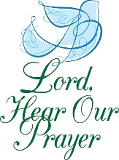**Prayer Request List**

The Bartley Family, Sis. Charlton Baxter,Sis. Cynthia Broadus,Sis. Denise Brooks,Bro. Ronald Brooks,Sis. Sarah Campbell, Atty. Charles Craig, Rebecca T. Dent, Bro. Tyrone Foreman, Sis. Thelma Goodwin, Sis. Ruth Gordon, Deas. Elsie Hammond, Bro. Jersey Hilton, Deas. Mary Hodges (N.C.), Deas. Patricia Ireland, Bro. Wayne Ireland, Sis. Kandis Jacobs and Family, Bro. John Jackson, Sis. Tamiko Jackson and Family, Sis. Patricia Jackson, Deas. Sheila Jackson, Deas. Myrna Jolly and Family, Bro. Philip Jordan, Sis. Josephine Lawrence, Officer Lucas, Sis. Carolyn Kelly and Family, The Lewis Family, Sis. Rebecca King, The Martin Family, Sis. Linda Cox Miko, Sis. Angela Butler Mills, Bro. Leonard Mills, Deas. Ozella Mitchell, Sis. Cheryl Morning, Bro. Richard Noble, Bro. Elmer Powell, Sis. Lois Pulliam, Sis. LaNiece Proctor, The Quick Family, Sis. Diamond Scott, Sis. Stephanie Scott, Sis. Constance Smith, Bro. Rufus T. Stevenson, Deas. Georgia Thomas, Bro. Danny Tonzi, Two Year Old Joseph, Sis. Belinda Williams, Bro. Dwight Wilson, Bro. Leroy Wilson

Men and Women in Military Service

The People of Cameroon

The Young People of DACA

The Victims of Gun Violence

Those Looking for Work

Victims of the coronavirus

**Prayer list**

Please contact the church office to have names added to our Prayer Request List.

**Welcome Sister Wendy Young**

The church family is happy to welcome Wendy Young as a member of our fellowship. The Right Hand of Fellowship was given last Sunday. Please welcome Sis. Young to the family.

**Mrs. Evelyn Bullock**

The church family is saddened by the passing of Mrs. Evelyn Bullock. Mrs. Bullock was the sister of Deas. Myrna Jolly. Please keep Deas. Jolly and the family in your prayers.

**Announcements**

**Church Giving**

You can give to Second Baptist Church by a one-time contribution, a weekly or a monthly recurring gift with a check or money order.  You are urged to send your check or money order to

Please give notices and announcements of vital statistics, important events and other news for the *Second Hands* to the church office by **Wednesday** preceding the Sunday on which you wish publication We thank you for your input.

Church Office: 202.842.0233 * Facsimile: 202.842.4574 * Email: [sbcnwdc@verizon.net](mailto:sbcnwdc@verizon.net) * Website: [www.secondbaptistchurchdc.org](http://www.secondbaptistchurchdc.org)

If you would like to get in touch with our pastor, Dr. Terrell, you can contact him at: 202-841-2479 or 202-584-1524.

Rev. James S. Terrell, Assistant to the Pastor

James Shird, Chairman, Board of Deacons

Vernelle Hamit, Chairman, Board of Trustees

Wandra Brown, Chairman, Board of Deaconesses

Second Baptist Church

816 Third Street, NW

Washington, D.C. 20001

Know that you will be supporting our mission of preaching the Gospel and your donations will be much appreciated. You can also give to the church through Cash App for the church is 202-841-2479.

**Please Vote**

**Election Day is Tuesday, November 3, 2020 Please Vote**

**Registration voting deadlines**

In person: Nov. 3

**Absentee ballot deadlines**

Request: Oct. 27

Return by mail: Postmarked by Nov. 3

Return in person: Nov. 3 by 8:00 p.m.

**Early Voting**

Oct. 27 - Nov. 2. Dates and hours may vary based on where you live

For more information, please visit <https://www.dcboe.org/>

**2020 DCBC Annual Gathering**

The DC Baptist Convention Annual meeting will be held on Thursday, October 22 at 1:30 p.m. To obtain a ticket to the “Embrace: Rediscovering the Call to Fellowship”, please visit <https://www.dcbaptist.org/annual-gathering-2020>. Tickets are free to $20.

**Covid-19 Worship**

In order to meet DC Covid-19 Guidelines, we must limit our services to no more than fifty persons. Congregants are asked to register with the Church office prior to worship. Only registered persons may be admitted to the church building. All others may watch the service in their cars on the parking lot.