**Second Baptist Church, est. 1848**

**816 Third Street, N.W., Washington, D.C. 20001**

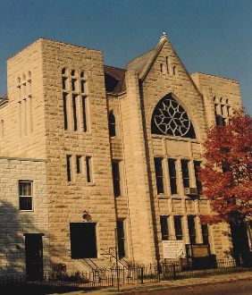

SECOND HANDS

**VOLUME XXI Number 25**  **Sunday, June 21, 2020**

**Annual theme:  *Loving God with All Our Heart”***

Master, which is the great commandment in the law? Jesus said unto him, Thou shalt love the Lord thy God with all thy heart, and with all thy soul, and with all thy mind. This is the first and great commandment.

Matthew 22:36-38

**OUR CALENDAR**

**AT A GLANCE**

**Today, Sunday, June 21**

**11:00 a.m.** Worship Service on Facebook http://www.facebook.com/secondbaptistchurchdc, Rev. Dr. James E. Terrell, Preaching

Father’s Day

**Tuesday, June 23**

**6:00 p.m.** Bible Study and Prayer Meeting at Church or by Telephone, 1-866-783-6229 Use code 712634#

**Sunday, June 28**

**11:00 a.m.** Worship Service

**Tuesday, June 30**

**6:00 p.m.** Bible Study and Prayer Meeting by Telephone, 1-866-783-6229 Use code 712634#

**Saturday, July 4**

Independence Day

**Sunday, July 5**

**11:00 a.m.** Worship Service

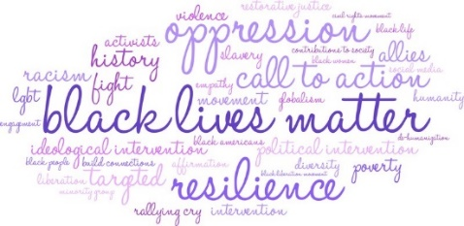

Please send any news or announcements for *Second Hands* to the church before 10:30 a.m. on the **Wednesday** preceding publication.

Church Office: 202.842.0233 * Facsimile: 202.842.4574 * Email: [sb**c**nwdc@verizon.net](mailto:sbcnwdc@verizon.net) * Website: [www.secondbaptistchurchdc.org](http://www.secondbaptistchurchdc.org)

**Congregational Prayer**

Eternal and Ever-Gracious God and Father, with eager and earnest hearts we are seeking your favor as we join in spirit to worship You.

Help us to cultivate every noble instinct and every lofty impulse and may we strive humbly and reverently to make our whole lives a reflection of the true, the beautiful and the good. Deliver us from all fear and grant that under the guidance of the Holy Spirit we may discover and develop our better selves. Hear us in the name of Jesus. Amen.

**Sermon Information**

**Scripture** I Thessalonians 2:11-12

**Sermon** “A Compelling Model”

*“That ye would walk worthy of God, who hath called you unto his kingdom and glory.” (I Thessalonians 2:12)*

**Summary:**  We greatly recommend mildness and tenderness to others. These qualities are most like God’s graciousness. This is the way to win people. We must be faithful in our calling to all callings. Our duty is to walk worthy of our calling.

**SBC Worship Service**

The District is now in Phase 2 of the Covid-19 Trial. On Sunday, June 28, Second Baptist will return to worship in the Lower Sanctuary and sitting six feet apart with people wearing masks. You may also find Sunday’s sermon on [www.facebook.com/secondbaptistchurchdc](http://www.facebook.com/secondbaptistchurchdc). Once on our page, go to Posts.

**Prayer Meeting**

The Tuesday Prayer Meeting will meet at the Church on June 23 at 6:00 p.m..

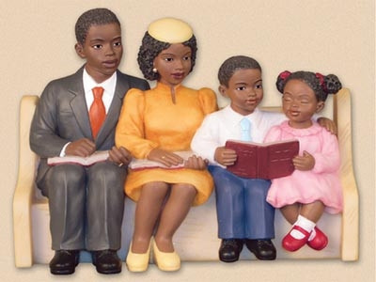

**Verse of the Week**

“But Jesus beheld them, and said unto them, With men this is impossible; but with God all things are possible.”

***Matthew 19:26***

**June Birthdays**

|  |  |  |
| --- | --- | --- |
| Mary Terrell | 3 |  |
| Romell Taylor | 6 |  |
| DeVyn Anthony Cannon | 7 |  |
| Michael Green | 7 |  |
| Jeremiah Heath | 11 |  |
| Derrick Wilson | 11 |  |
| Eric Wilson | 11 |  |
| James P. Terrell | 12 |  |
| Ophelia Scott | 13 |  |
| Angela Heath | 14 |  |
| Melinda Smith | 14 |  |
| Claressa Campbell | 17 |  |
| Nadege Chofor | 18 |  |
| Kandis Jacobs | 20 |  |
| Tamiko Jackson | 20 |  |
| Stephanie Scott | 20 |  |
| Selassie Taylor | 20 |  |
| Tyletta Dodoo | 22 |  |
| Marcia Harris | 24 |  |
| Xiomara Terrell | 24 |  |
| Rodney Hill | 25 |  |
| Evelyn Roberts | 26 |  |
| Diamond Scott | 27 |  |
| Faye Smith | 27 |  |
| Michelle McDaniels | 28 |  |

**Wedding Anniversary**

Barbara J. Durham and Raheem Rasta will “Jump the Broom” again on Sunday, June 21

Deacon Carrol and

Deaconess Sheila Jackson

June 26 and June 27

[](https://www.google.com/url?sa=i&rct=j&q=&esrc=s&source=images&cd=&cad=rja&uact=8&ved=2ahUKEwi2tovEytTfAhXsRd8KHf_RC_0QjRx6BAgBEAU&url=https://www.pinterest.com/pin/92183123602680565/&psig=AOvVaw3lgoEWcWMrl9LcePVwFPiC&ust=1546706935386683)

**Prayer List**

The Bartley Family

Sis. Charlton Baxter

Please give notices and announcements of vital statistics, important events and other news for the *Second Hands* to the church office by **Wednesday** preceding the Sunday on which you wish publication We thank you for your input.

Church Office: 202.842.0233 * Facsimile: 202.842.4574 * Email: [sbcnwdc@verizon.net](mailto:sbcnwdc@verizon.net) * Website: [www.secondbaptistchurchdc.org](http://www.secondbaptistchurchdc.org)

If you would like to get in touch with our pastor, Dr. Terrell, you can contact him at: 202-841-2479 or 202-584-1524.

Rev. James S. Terrell, Assistant to the Pastor

James Shird, Chairman, Board of Deacons

Vernelle Hamit, Chairman, Board of Trustees

Wandra Brown, Chairman, Board of Deaconesses

Sis. Cynthia Broadus

Sis. Denise Brooks

Bro. Ronald Brooks

Sis. Sarah Campbell

Atty. Charles Craig

The Willie Dunham Family

The Gatling Family

Sis. Thelma Goodwin

Sis. Ruth Gordon

Deas. Elsie Hammond, *at home*

Deas. Mary Hodges (N.C.)

Tr. Vernelle Hamit and Family

Bro. Wayne Ireland

Sis. Kandis Jacobs and Family

Sis. Tamiko Jackson and Family

Sunday, June 21, 2020 Page 2 Second Hands

Sis. Patricia Jackson

Deas. Sheila Jackson

Sis. Josephine Lawrence

Officer Lucas

Sis. Carolyn Kelly and Family

The Lewis Family

Sis. Doris Little and Family

Sis. Rebecca King

Sis. Marjean Rae Martin

Sis. Linda Cox Miko

Sis. Angela Butler Mills

Bro. Leonard Mills

Deas. Ozella Mitchell

Sis. Cheryl Morning

Bro. Richard Noble

The Nolton Family

Bro. Elmer Powell

Sis. Lois Pulliam

Sis. LaNiece Proctor

The Quick Family

Sis. Diamond Scott

Sis. Stephanie Scott

Sis. Constance Smith, *at home*

The Smith Family

Sis. Fonda Stephens-Kelly

Bro. Rufus T. Stevenson

Deas. Georgia Thomas

Two Year Old Joseph

Sis. Belinda Williams

Bro. Dwight Wilson

The James Wilson Family

Bro. Leroy Wilson

Men and Women in Military Service

The People of Cameroon

The Young People of DACA

The Victims of Gun Violence

Those Looking for Work

Victims of the coronavirus



**Stewardship Sunday**

Thank you, Second Baptist Church members for sending in your 2020 Spring Stewardship offering. Your support will enable the Church to defray the cost of this summer’s utility bills. May God continue to bless each of you.

**Announcements**

**DC Baptist Convention**

The DC Baptist Convention has selected Rev. Dr. Trisha Miller Manarin as the next Executive Director/Minister. Dr. Manarin will start her new position on August 17, 2020.

**DC Covid-19 Testing**

Covid-19 Testing for DC residents is available at The Pennsylvania Avenue Baptist Church at 3000 Pennsylvania Avenue, SE by appointment only. Please call 202-865-2109 to schedule an appointment.

**Help Wanted**

Wanted, Monday through Friday baby-sitter for two small girls, an infant and a five year old. For more information, please contact Ms. Esther Smith at 202-891-9300.