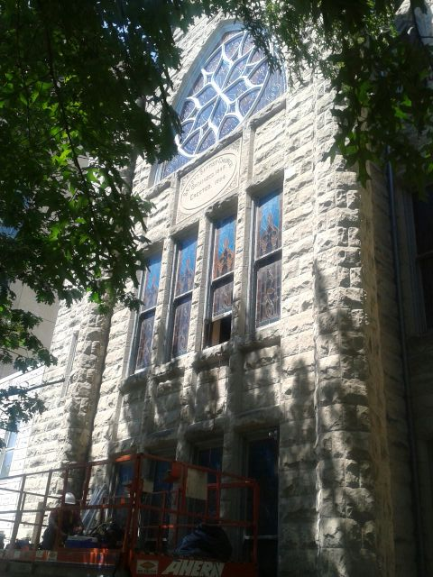
SECOND HANDS

Second Baptist Church, established 1848
816 Third Street, N.W., Washington, D.C. 20001

VOLUME XV Number 14 Sunday, April 4, 2021

Our Annual Theme: “Sharing the Hope That Is in Us”

I Peter 3:14-15 - But even if you should suffer for righteousness' sake, you will be blessed. Have no fear of them, nor be troubled, but in your hearts honor Christ the Lord as holy, always being prepared to make a defense to anyone who asks you for a reason for the hope that is in you, yet do it with gentleness and respect.

CALENDAR
AT A GLANCE

Sunday, April 4 11:00 a.m. Easter,
Dr. James E. Terrell, Preaching
Sunday, April 11 11:00 a.m. Holy Communion,
Min. Matthew Wills, Preaching
Emancipation Sunday
Tuesday, April 14 6:00 p.m. Bible Study and Prayer Meeting*, Romans 2 and 3
Friday, April 16 Emancipation Day Observed

*Prayer Meeting and Bible Study Conference Call-In
1-866-783-6229 Code 712634#

Prayer of the Week
Almighty God, whose amazing love we cannot fathom in this Holy Week with its days of solemn and sacred memory, may we be filled with Your humble spirit and contrite heart as we meditate upon the sufferings and sacrifice of our Lord Jesus.

Help us so that on this Easter Sunday we may share His glorious resurrection by rising with Him into a newness of life and rededicating ourselves to the task of building that blessed the highway to heaven where nations walk and work together in His spirit. Inspire us with joyous conviction that we are living and laboring for the Kingdom of God and its righteousness which can only be established through the power of sacrificial love. We pray in the glorious name of Jesus. Amen.

Verse of the Week
One thing have I desired of the Lord, that will I seek after; that I may dwell in the house of the Lord all the days of my life, to behold the beauty of the Lord, and to inquire in his temple. Psalm 27:4

Weekly Bible Reading

Joshua 1:8 Keep this Book of the Law always on your lips; meditate on it day and night, so that you may be careful to do everything written in it, then you will be prosperous and successful.

This week we are studying Romans 2 and 3

Happy Easter

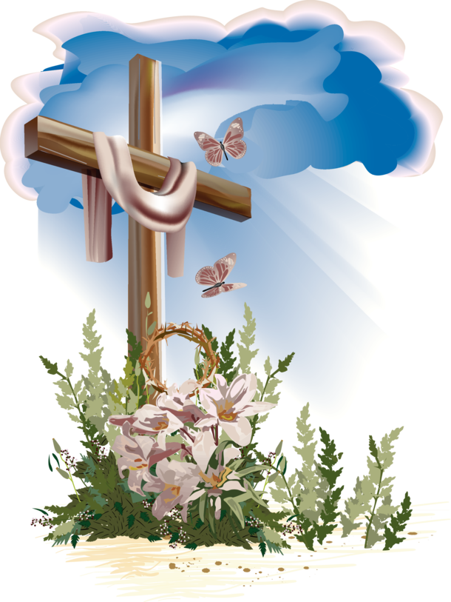

Visitors
We warmly welcome you to Second Baptist Church. We hope that you will experience God’s love and presence in worship today. Please sign our guest book and plan to come again. If you are looking for a Church Home, we hope you find one here.

Word of the Week:
"Easter is the demonstration of God that life is essentially spiritual and timeless.”~ Charles M. Crowe.

Covid-19 Worship
Please keep our Church Family and Community in prayer. Please pray, wear a mask, follow the six-foot social distancing guidelines and follow hygiene directives. If you are unable to attend Sunday Worship, please hear and see the service and speaker on Facebook.

See Us on Facebook
You may find today’s Sunday Sermon on www.facebook.com/secondbaptistchurchdc. Once on our page, go to “Posts”. You may view prior services on Facebook as well.

April Birthdays
Zsudayka Terrell 6, Kamari Bennaugh 6, Clinton Vasquez 7, Lary Calloway 7, Myra Robinson 11, Ozella Mitchell 11, Vernelle Hamit 11, Kyra Vasquez 16, Addie Mack 18, Christopher McDaniels 23, Mariessa T. White 24, Wanda Scales 24, Erica Smith 29, Jackie Braxton 29

Communion, Hospital and Home Visits If you or someone you know would like to be visited by the pastor, please call the church office to make arrangements.

Pastor’s Office Hours Our Pastor Rev. James E. Terrell holds office hours on Tuesday and Thursday from 9:00 a.m. to 11:00 a.m. and by appointment.

Church Giving: Your donations will be much appreciated. You may send your check or money order to Second Baptist Church, 816 Third Street, NW Washington, D.C. 20001. Please know that you will be supporting our mission of preaching the Gospel. You may also give to the Church through Cash App by using 202-841-2479.

Prayer Requests
Please remember to pray for:
The Bartley Family, Charlton Baxter, The Battle Family,
Sis. Cynthia Broadus, Sis. Denise Brooks,

Bro. Ronald Brooks, Sis. Sarah Campbell,
Atty. Charles Craig, Sis. Irene Coleman,
Sis. Viola Crawley,
Bro. Ashby Dalton,
Sis. Eleanor Dunham, Sis. Rebecca T. Dent,

Bro. Tyrone Foreman, Sis. Thelma Goodwin,

Sis. Ruth Gordon, Deas. Elsie Hammond,

Bro. Jersey Hilton, Deas. Mary Hodges (N.C.),

Deas. Patricia Ireland, Bro. Wayne Ireland,

Sis. Kandis Jacobs and Family, Bro. John Jackson,

Sis. Tamiko Jackson and Family, Sis. Patricia Jackson, Deas. Sheila Jackson, Deas. Myrna Jolly and Family,

Bro. Philip Jordan, Sis. Josephine Lawrence,
Officer Lucas,
Sis. Carolyn Kelly and Family,
The Lewis Family,
Sis. Genevieve Lucas, Sis. Rebecca King,

The Martin Family, Sis. Susan Meehan,

Sis. Linda Cox Miko, Sis. Angela Butler Mills and Family,

Bro. Leonard Mills, Deas. Ozella Mitchell,
Sis. Cheryl Morning, Bro. Richard Noble,
Bro. Elmer Powell, Sis. Lois Pulliam,
Sis. LaNiece Proctor, the Quick Family,
Sis. Diamond Scott, Sis. Stephanie Scott
Sis. Constance Smith, Bro. Rufus T. Stevenson,
Deas. Georgia Thomas, Bro. Danny Tonzi,
Two Year Old Joseph, Sis. Belinda Williams,

Bro. Dwight Wilson, Bro. Leroy Wilson, Men and Women in Military Service, the People of Cameroon, The Young People of DACA The Victims of Gun Violence, People Looking for Work, Victims of the corona virus
Prayer List Please contact the Church Office to have names added to our Prayer Request List.

Announcements

Leaders of Tomorrow Scholarship for 2021
Tomorrow Black Men is providing Leaders of Tomorrow Scholarships for African-American male high school students who show academic and community leadership in the DC Metro area. The levels of awards of $500, $1,000, $2,500 will be awarded to students graduating at the end of the 2020-2021 school year. 1. Contact the church office for an application packet. For more information or questions, please email scholarship@tomorrowsblackmen.org. Applications must be submitted by May 15, 2021

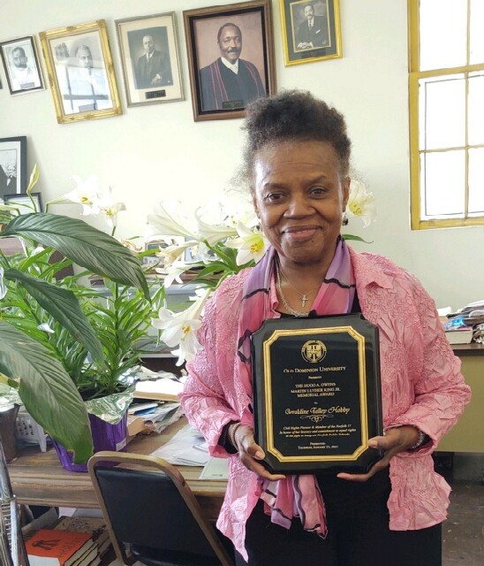
Mrs. Geraldine Talley Hobby exhibits her plaque for being one of the Norfolk Seventeen children who were the plaintiffs in the integrating of the Norfolk, VA Schools in Brown vs. Board of Education. Mrs. Hobby is writing a book about the desegregation of U.S. Schools. She is a member of Bible Way Church of New York City and a great friend of Second Baptist Church.

